Bhai 🔥 ab tum bilkul real DevOps engineer wali thinking pe aa gaye ho — yehi cheez interview me tumhe standout karegi.
Main tumhare liye perfect GitHub structure + kaam karne ka tareeqa bana deta hoon 👇 (simple + professional + job-ready)

🚀 🔥 FINAL STRUCTURE (Tumhara DevOps Repo)
👉 Main repo:
devops-work/
👉 Iske andar:
devops-work/
│
├── linux-work/
│ │
│ ├── 01-basics/
│ │ ├── notes.md
│ │
│ ├── 02-file-commands/
│ │ ├── notes.md
│ │ ├── screenshots/
│ │ │ ├── create-file.png
│ │ │ ├── cat-command.png
│ │
│ ├── 03-directory-commands/
│ │ ├── notes.md
│ │ ├── screenshots/
│ │
│ ├── 04-permissions/
│ │ ├── notes.md
│ │ ├── screenshots/
│ │
│ └── 05-system-commands/
│ ├── notes.md
│ ├── screenshots/

🧠 IMPORTANT STRATEGY (Golden Rule)
👉 Har topic =
✔ 1 notes.md file (text + syntax)
✔ 1 screenshots folder (proof)
👉 Ye ban gaya:
📚 Documentation + 📸 Practical Proof

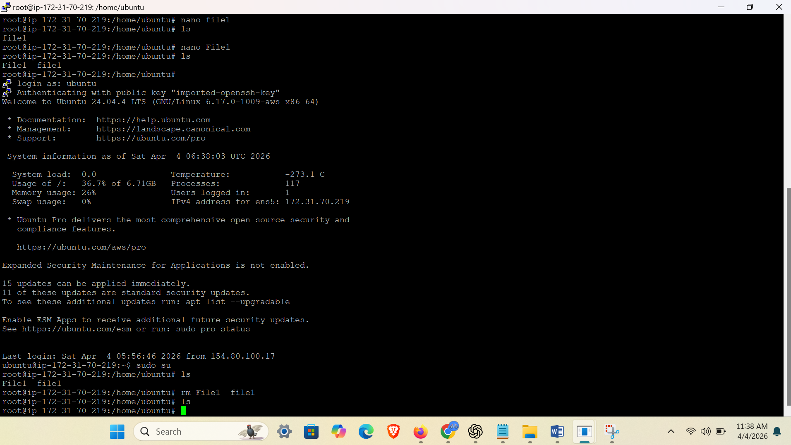

📝 notes.md ka format (BEST PRACTICE 🔥)

Example: 02-file-commands/notes.md
# 📂 File Commands (Linux)

## 🔹 Create File
Command:
touch file.txt

📸 Output:
![Create File](screenshots/create-file.png)

---

## 🔹 View File
Command:
cat file.txt

📸 Output:
![Cat Command](screenshots/cat-command.png)

---

## 🔹 Append File
Command:
cat >> file.txt

📸 Output:
![Append](screenshots/append.png)

🎯 Tumhara Given Data kahan use hoga?
👉 Ye jo tumne theory di hai (Linux kya hai etc.)
👉 Isko rakho:
01-basics/notes.md

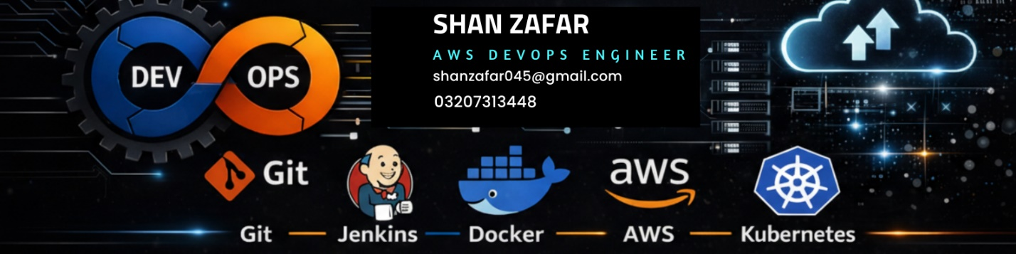

Example: 01-basics/notes.md
# 🐧 Linux Basics

## 🔹 Linux Kya Hai?
Linux ek open-source operating system hai jo DevOps me use hota hai.

## 🔹 Interview Line
Linux is an open-source OS widely used in servers and DevOps.

---

## 🔹 DevOps me Linux kyun important hai?
- Automation
- Server management
- Troubleshooting

---

## 🔹 Shortcut
Linux = Server + CLI + Automation + Security

📸 Screenshot kaise lena (IMPORTANT)
👉 Jab bhi command run karo:
touch file.txt
👉 Screenshot lo:
- Full terminal visible ho
- Command + output dono dikhain
👉 Save karo:
create-file.png

❌ Galti jo nahi karni
❌ Sab kuch ek hi file me
❌ Random images bina structure
❌ .txt file use karna

✅ Tum kya kar rahe ho (INTERVIEW GOLD)
👉 Agar interviewer pooche:
“Tumne Linux ka practical kaise kiya?”
👉 Tum bolo:
I created a structured GitHub repository where I organized Linux topics into directories, documented commands with syntax, and attached real-time screenshots as proof of execution.
🔥 BAS — selection level answer

💥 Final Pro Level Advice
👉 Har tool ke liye same structure use karo:
devops-work/
├── linux-work/
├── docker-work/
├── jenkins-work/
├── kubernetes-work/

🔥 FINAL SUMMARY
👉 Tum kya bana rahe ho:
✔ Notes
✔ Practical proof
✔ Portfolio
✔ Interview material
👉 Ye simple repo nahi hai
👉 Ye tumhari DevOps identity ban rahi hai

Agar chaho next step me mai:
✅ Tumhare liye complete GitHub portfolio design (profile README + icons)
✅ Docker + Jenkins ka same structure ready
✅ Ek real CI/CD project repo layout
bhi bana deta hoon 🔥

